|  |
| --- |
|  |
| UIUX Assignment |
| 202208793 |

Contents

Part 1 – Cognitive Walkthrough 2

Case Study 1 – Hubble Portal: 2

Case Study 2 – Stack Overflow: 6

Part 2 – Iterative Prototype Design 11

Case Study 1 – Student Mental Health Check-In 11

User Goals: 11

Low Fidelity 12

High Fidelity 13

# Part 1 – Cognitive Walkthrough

## Case Study 1 – Hubble Portal:

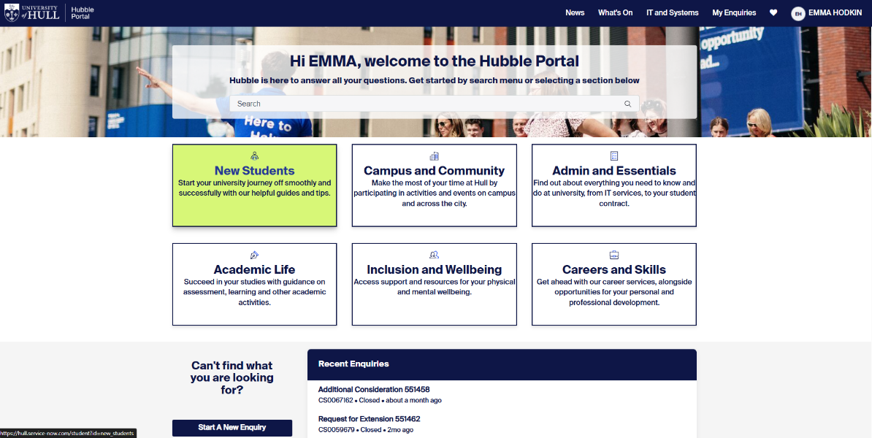

Very clear indication of which box is being selected. This conforms with Nielsen’s first heuristic, that of visibility of system status (Gonzalez-Holland et al., 2017)

Clearly labelling and expanding upon the box titles gives affordances to the user so they can understand each action at a glance (*Don Norman’s Principles of Interaction Design | by Sachin Rekhi | Medium*, 2017)

Figure 1 - Hubble home page

Goal: Find the Mental Health Support page.

Step 1: Access the “Inclusion and Wellbeing” page

* Q: Is the page visible?
* A: Yes, everything loaded very quickly
* Q: Would you know where to go without being told?
* A: Yes, the box is clearly labelled and has a subtitle to guide me to the right area.
* Q: Is there any visual feedback on progressing to the next page?
* A: Yes, the box changes colour when hovered over and the new page loads quickly.

Step 2: Access the “Wellbeing & Inclusion” page

Figure 2 - Inclusion & Wellbeing page

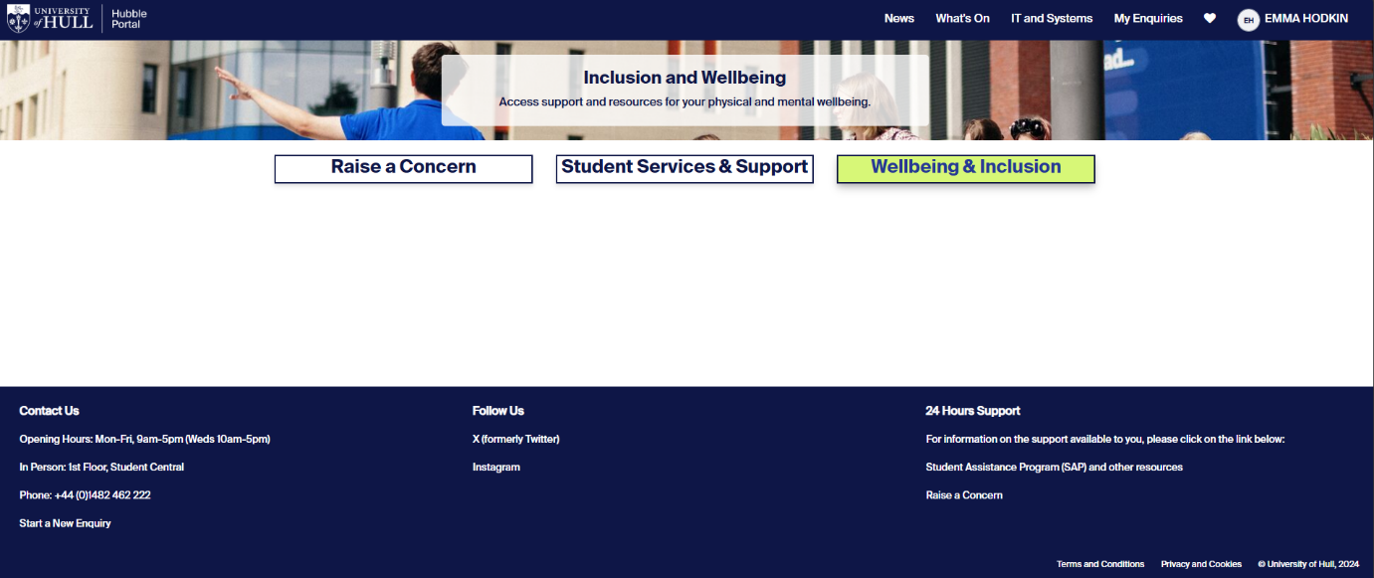

Unlike the previous page, the design is now more minimalist, but instead of this reducing confusion, there is now so little information that we don’t know where to go. This conflicts with Nielsen’s heuristic: Aesthetic and minimalist design. (Gonzalez-Holland et al., 2017)

This page has no visible back or “exit” method, making the user feel trapped in their choices. This goes against Nielsen’s heuristic of User Control and Freedom, where the user should feel free to explore the webpage without fear of constraints. (Gonzalez-Holland et al., 2017)

* Q: Does the page load correctly?
* A: Yes, although the page has no explanations or shows what each function does.
* Q: Would you know where to go without being told?
* A: No, there are two other options I would consider as there are no signposts.
* Q: Is there any visual feedback on progressing to the next page?
* A: Yes, the box changes colour when hovered over and the new page loads quickly.

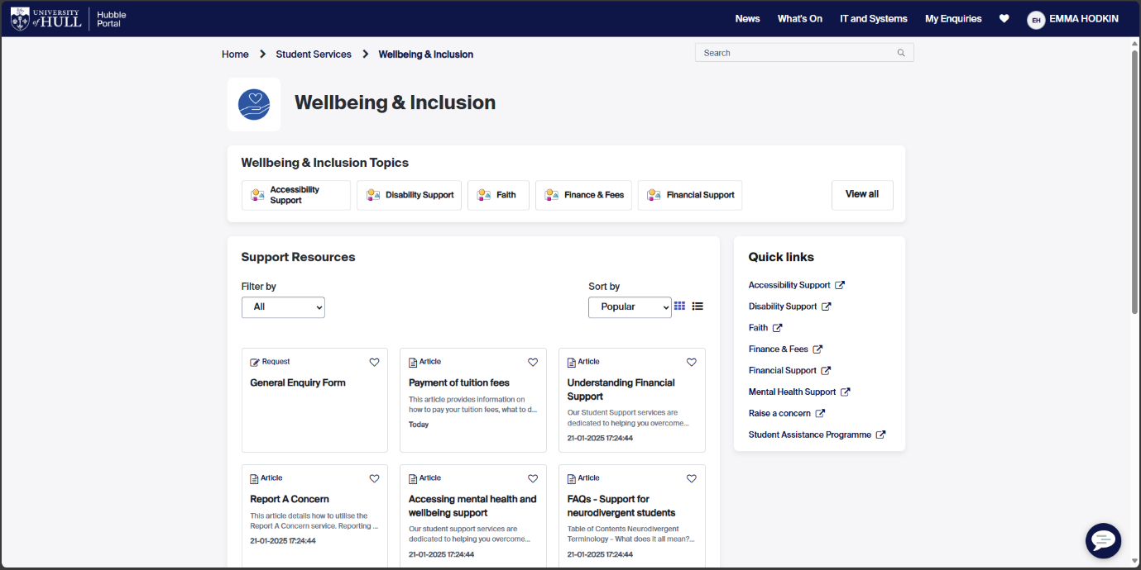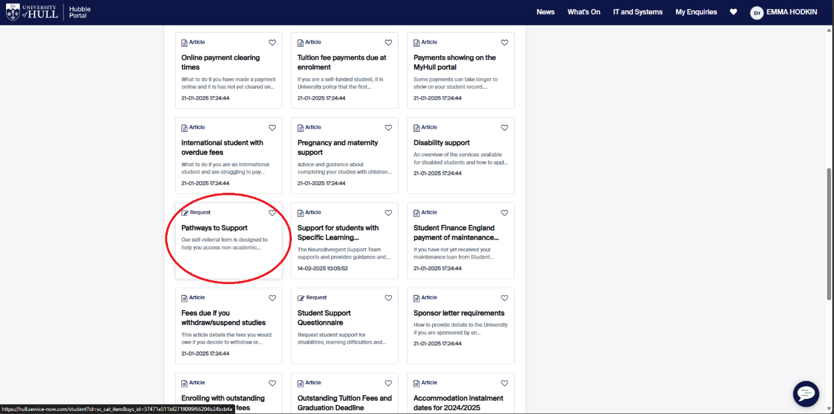

Despite the overall UI change between pages, the consistency of the box method of tabs makes the user feel like they’re still on a continuous website. This follows on from the heuristic of Consistency and Standards. (Gonzalez-Holland et al., 2017)

As all the articles are tightly packed, it makes them harder to see, this contradicts Norman and Nielsen’s ideas of Visibility and Minimalism. (*Don Norman’s Principles of Interaction Design | by Sachin Rekhi | Medium*, 2017), (Gonzalez-Holland et al., 2017)

Figure 3 - Wellbeing & Inclusion resources page

Step 3: Access the “Pathways to support” article

* Q: Is the article easy to find?
* A: Not really, the boxes are small and there are many of them.
* Q: Would you know where to go without being told?
* A: yes, but only after a lot of looking.
* Q: Is there any visual feedback on progressing to the next page?
* A: No, the box doesn’t change when hovered over.

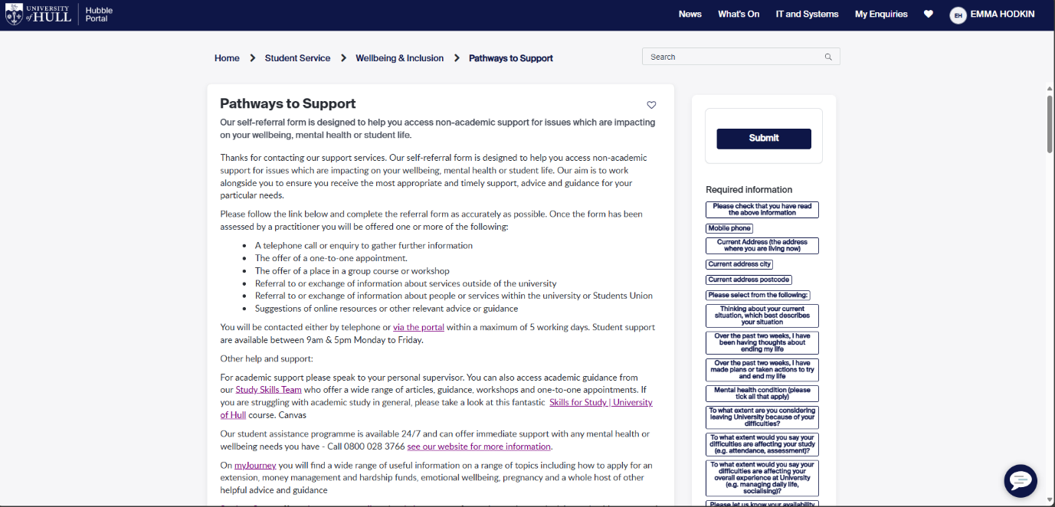

The page uses a blog post format to match between the system and the real world. (Gonzalez-Holland et al., 2017)

On the right there are “required field” boxes which correlate to the form at the bottom of the article, but each box is a different size, which breaks the Consistency rule. (*Don Norman’s Principles of Interaction Design | by Sachin Rekhi | Medium*, 2017)

Figure 4 - Pathways to Support request page

Step 4: Discover Mental Health Support page. (End State)

* Q: Was the article easy to find?
* A: Not really, there were many unlabelled or confusing options that would have taken me a while to get around before I found this page.
* Q: Would you know where to go without being told?
* A: Yes, but only after a lot of looking.
* Q: Was there any visual feedback on progressing through these steps?
* A: Sometimes, at the start the boxes would be labelled and change colour when hovered over, but other times it wasn’t.

## Case Study 2 – Stack Overflow:

Figure 5 - Stack Overflow home page

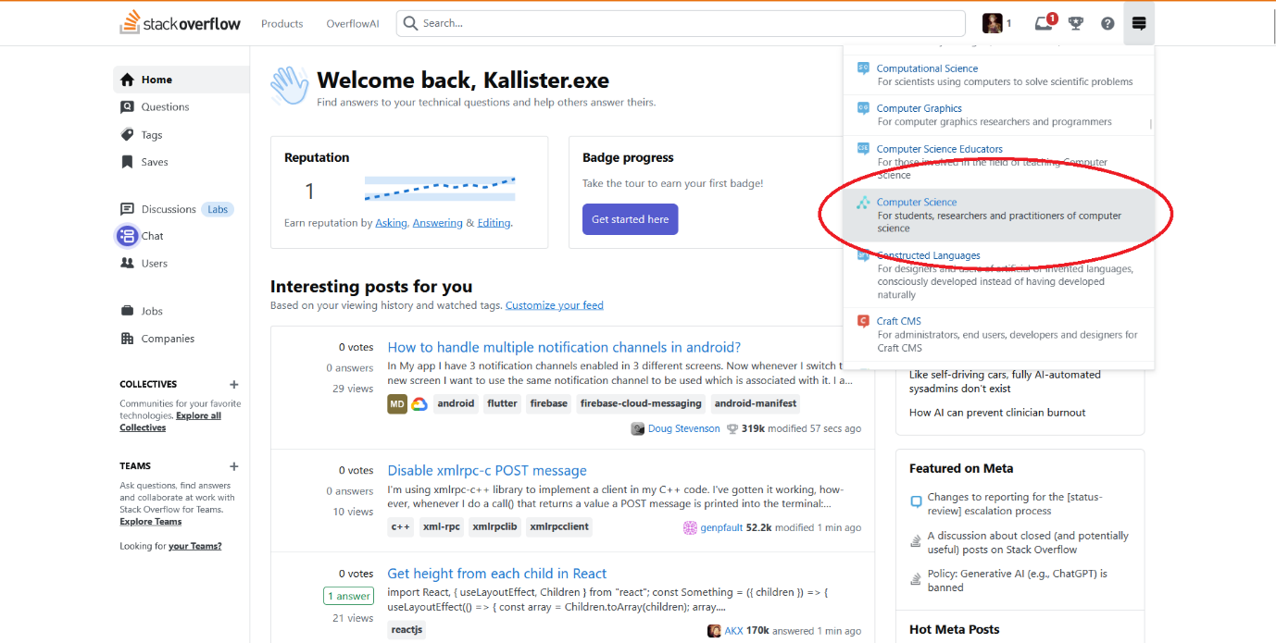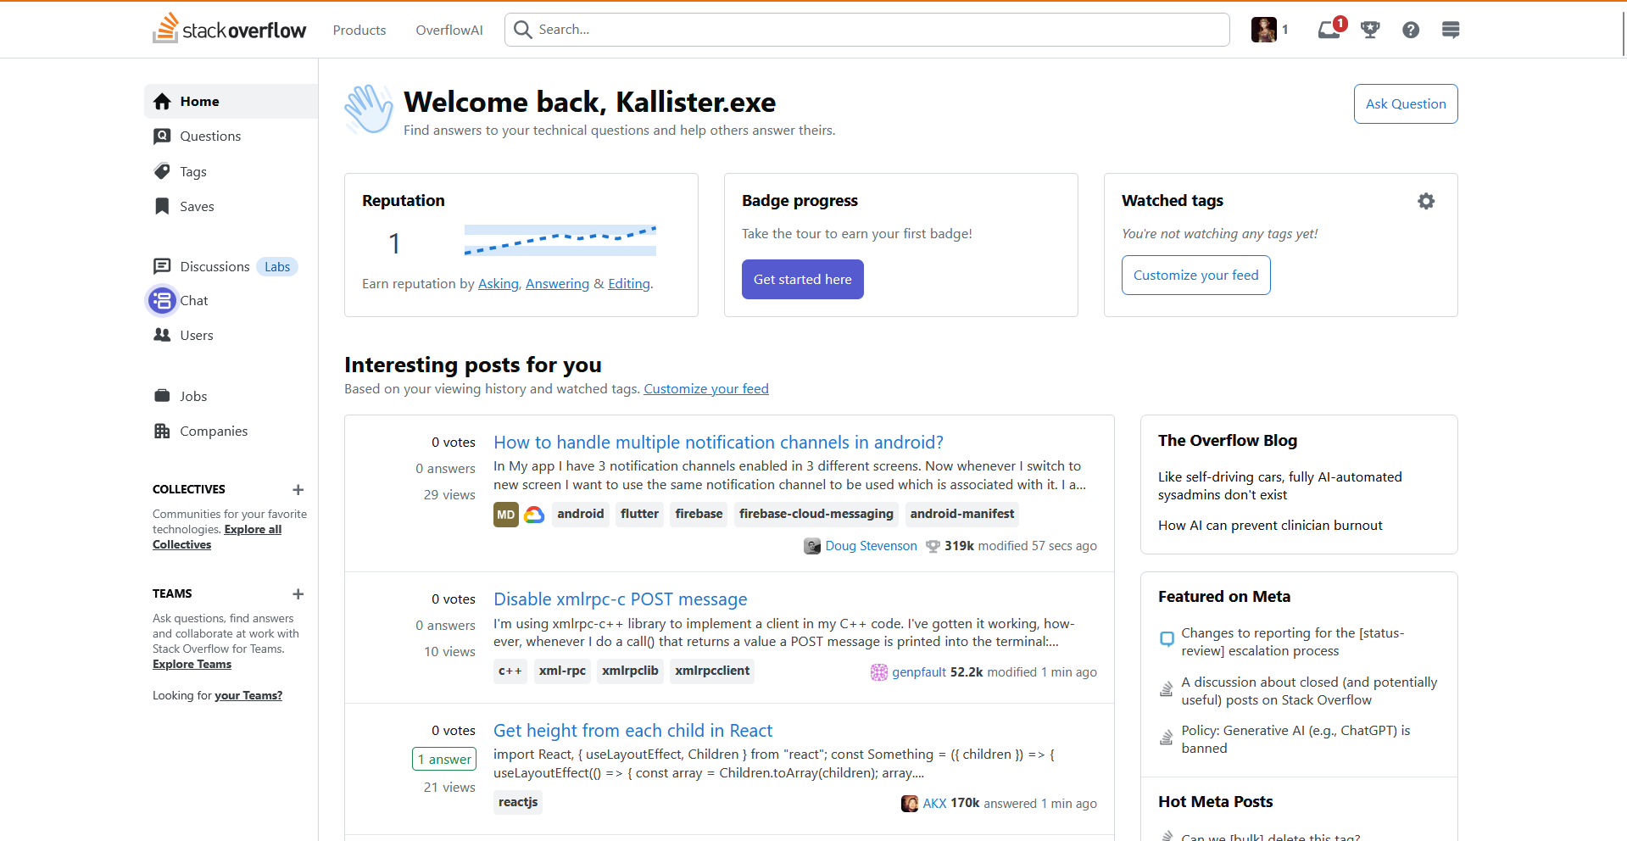

The UI of this webpage is very cluttered, with many metrics and features within view. The community tab is very small and not labelled with no discernible use. This opposes the minimalist idea put forward by both Neilsen and Norman. (Gonzalez-Holland et al., 2017), (*Don Norman’s Principles of Interaction Design | by Sachin Rekhi | Medium*, 2017)

The computer science tab is clearly highlighted when hovered over, given the user direct feedback of their actions as described by Don Norman. (*Don Norman’s Principles of Interaction Design | by Sachin Rekhi | Medium*, 2017)

Goal: Find a Turing Machine problem to help with.

Step 1: Access the “Computer Science” page from the stack exchange tab

* Q: Is the tab visible?
* A: Yes, but it’s not labelled and has no explanation.
* Q: Would you know where to go without being told?
* A: No, the page is very busy, and I wouldn’t know to use a small unlabelled tab.
* Q: Is there any visual feedback on progressing to the next page?
* A: Yes, the box changes colour when hovered over and the new page loads quickly.

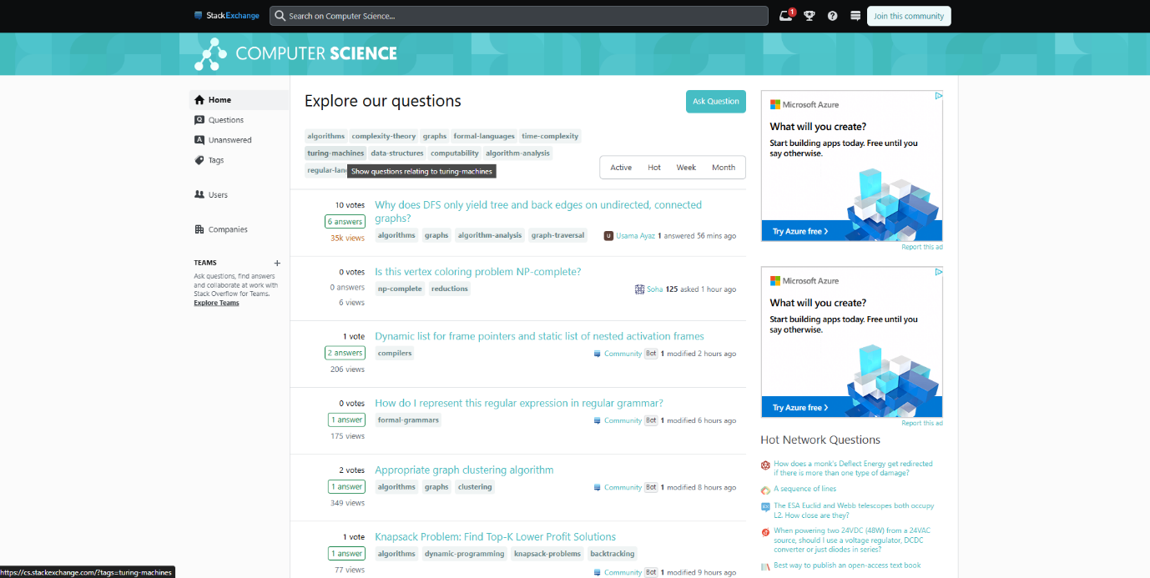

The page has a lot of options to filter a user’s search, from time to tags, the user has a lot of methods to tailor their experience. The user can also search for their question at the top, giving the user flexibility. (Gonzalez-Holland et al., 2017)

The UI is very cohesive on this page as it has a consistent colour scheme and the standard list of links for each question. (*Don Norman’s Principles of Interaction Design | by Sachin Rekhi | Medium*, 2017)

Figure 6 - Computer Science Community page

Step 2: Access the “Turing Machines” page from the questions list

* Q: Is the tab visible?
* A: Yes, but it’s not labelled and has no explanation.
* Q: Would you know where to go without being told?
* A: No, the page is very busy, and I wouldn’t know to use a small unlabelled tab.
* Q: Is there any visual feedback on progressing to the next page?
* A: Yes, the box changes colour when hovered over and the new page loads quickly.

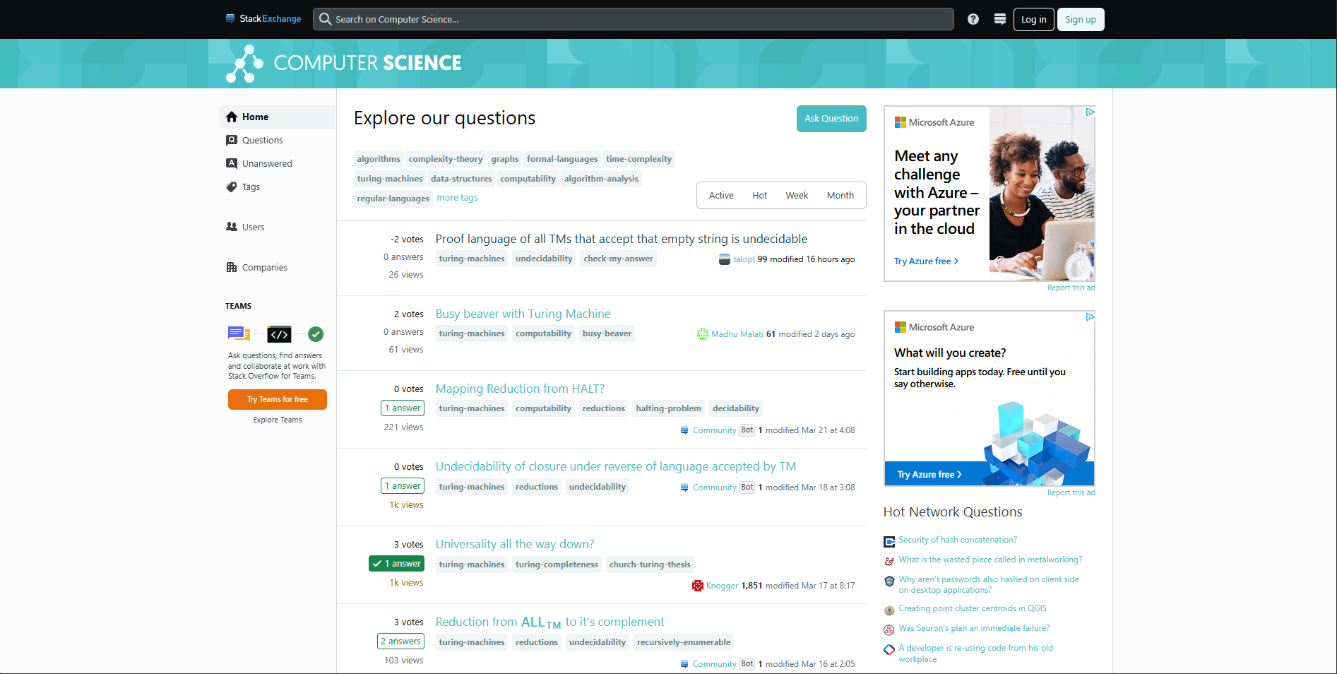

The link colour has changed after being clicked on, allowing the user to quickly identify which questions they have already viewed. This visual feedback removes the need to remember which questions have been seen, as described by Nielsen. (Gonzalez-Holland et al., 2017), (*Don Norman’s Principles of Interaction Design | by Sachin Rekhi | Medium*, 2017)

Like the previous case study, the website itself has no means of backtracking or exit functions, leaving the user locked into their choices. (Gonzalez-Holland et al., 2017)

Figure 7 - Computer Science Community page (filtered for Turing-machine questions)

Step 3: Access a question from the list

* Q: Is the question button visible?
* A: Yes, each question has a hyperlink and is coloured differently.
* Q: Would you know where to go without being told?
* A: Yes, once you have selected a question type, they are the only ones listed.
* Q: Is there any visual feedback on progressing to the next page?
* A: Yes, the hyperlink changes colour when hovered over and the new page loads quickly. The link also stays a new colour once clicked so if you navigate back, you know which questions you have viewed.

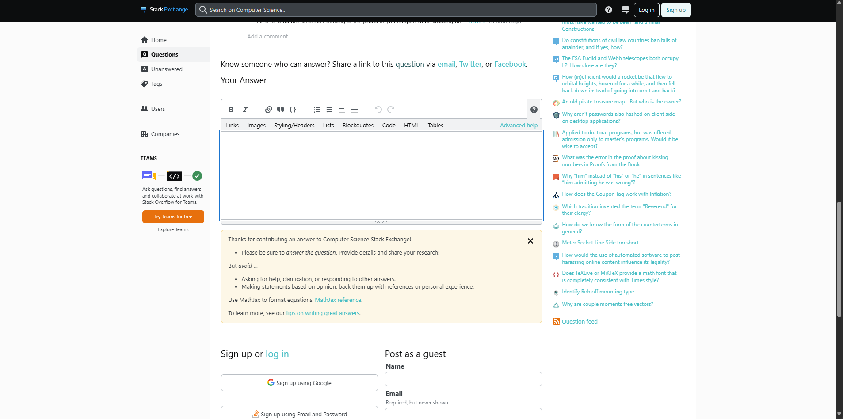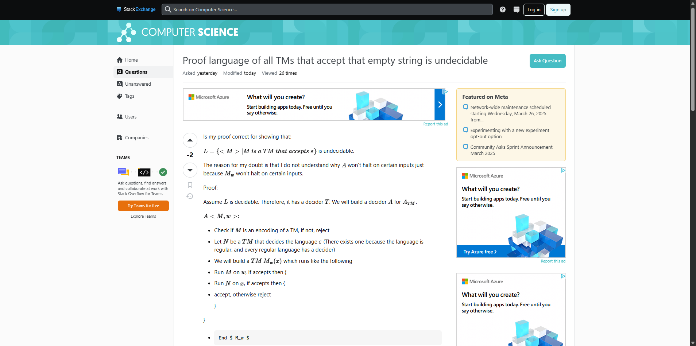

While the text box for answers is clearly visibly, the user has to scroll down past a warning and a request to log in before they see the submit button, which removes the easy mapping of the button and may confuse the user, antithetical to the mapping guidance given by Don Norman. (*Don Norman’s Principles of Interaction Design | by Sachin Rekhi | Medium*, 2017)

Figure 8 - Turing machine question

Step 4: View and answer the question (End State)

* Q: Is the submit answer button visible?
* A: Yes, each question has a hyperlink and is coloured differently.
* Q: Would you know where to go without being told?
* A: Not really, the answer sections is at the bottom of the question but the submit button is hidden under the sign-up/log-in section, so you’d have to scroll down to click it.
* Q: Is there any visual feedback on progressing to the next page?
* A: Yes, the submit button changes when hovered and gets smaller to mimic a real button press.

# Part 2 – Iterative Prototype Design

## Case Study 1 – Student Mental Health Check-In

### User Goals

Users:

* The Student
* The Personal Supervisor (PS)

User Goals:

* That a Student must be able to report any issues to the webapp easily.
* That a Student should be offered links and videos on improving mental health in the webapp.
* That a PS must be able to see all of the student reports allocated to that PS.
* That a PS should be able to arrange meetings with a Student either on-campus or via Teams.

Expansion:

Students may find it difficult to discuss mental health issues with their PS’s face-to-face as they may not yet have a good rapport with them. Allowing students a way to self-report any issues without direct contact would provide a way of expressing their needs less stressfully. Students also have busy schedules, with their university timetable, social commitments, and potentially a work rota, it is difficult to allocate time for PS meetings. The webapp could allow students to connect with their PS’s more effectively and arrange meetings around their busy schedules.

Personal Supervisors share many of the same issues as students, both with difficulty communicating and hectic diaries. As a PS, they can only work off of information they have, so being able to access all their allocated students’ submissions and overall health check-ins, they can at a glance know if one of their students is in need of extra help. PS’s also have busy schedules, between teaching hours and adult lives, many lecturers may not have a free hour in the day. By using the webapp to communicate between themselves and the student, they can better find a time to discuss any issues with synced calendars and the option for online or offline meetings.

### Student submits a report to the app

#### Low Fidelity

#### High Fidelity

General:

The colour scheme was chosen due to the associations of blue and the medical industry, especially the NHS as the app is oriented towards mental health. The colour blue is also known to have a calming effect which would be beneficial to students using the app (*How the Color Blue Impacts Moods, Feelings, and Behaviors*, 2024). The desaturated red is the contrast colour, and will be used to highlight certain areas and as an accessibility aid for those with colour-blindness or other visual impairments.

### Student requests a meeting with their PS

#### Low Fidelity

#### High Fidelity

### PS reviews a report from a Student

#### Low Fidelity

#### High Fidelity

### PS requests a meeting with their Student

#### Low Fidelity

#### High Fidelity

## Case Study 2 – Home Automation app

### User Goals

Users:

* Homeowner

User Goals:

* The Homeowner can toggle their lights, heating, and A/C using the app
* The Homeowner can track their usage of each feature
* The Homeowner should be able to set routines for their peripherals, prompted by the app.
* The Homeowner could be provided methods of reducing unnecessary wastage.

Expansion:

As the user goes through their week, the app could monitor usage of lights/heating and at what times to create a pattern or “Routine” for the user, which over time could reduce emissions and create better behaviours for the homeowner regarding their light pollution and energy efficiency.

### The Homeowner toggles lighting/heating

#### Low Fidelity

#### High Fidelity

### The Homeowner can see their overall usage over a given period

#### Low Fidelity

#### High Fidelity

### The Homeowner can use a recommended routine or set one of their own

#### Low Fidelity

#### High Fidelity

### The Homeowner can be notified of opportunities to reduce emissions

#### Low Fidelity

#### High Fidelity